Client:

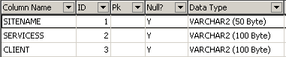

Cloud

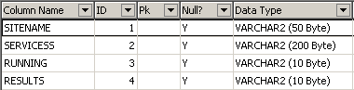

RANDOMTABLE:

